Write a query to display the name (first name and last name) for those employees who get more salary than the employee whose ID is 163.

select first_name,last_name

from employees

where salary > (select salary from employees where employee_id=163)

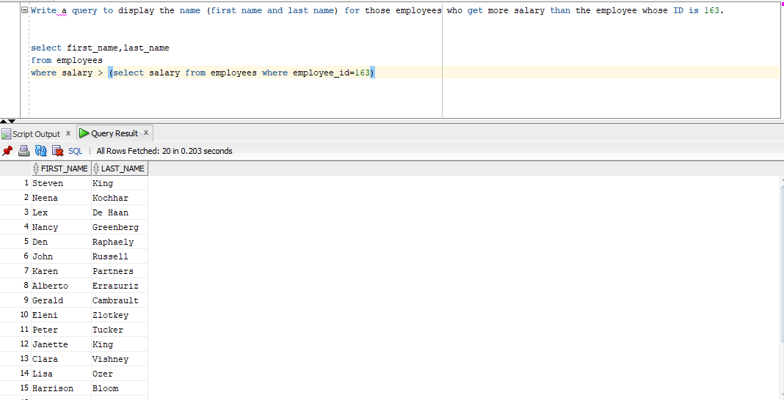

Write a query to display the name (first name and last name), salary, department id for those employees who earn

such an amount of salary which is the smallest salary of any of the departments.

select first_name,last_name,salary,department_id as deptid

from employees

where salary in(select min(salary) from employees group by department_id)

select first_name,last_name,salary,department_id as deptid

from employees

where salary =any (select min(salary) from employees group by department_id)

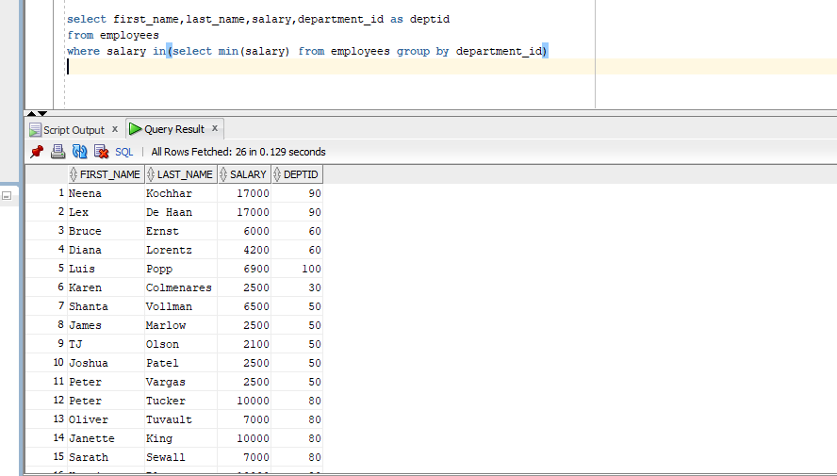

Write a query to display the department number, name (first name and last name), job_id and department name for

all employees in the Finance department.

select first_name,last_name,job_id,department_name

from employees e,departments d

where e.department_id=d.department_id

and department_name='Finance';

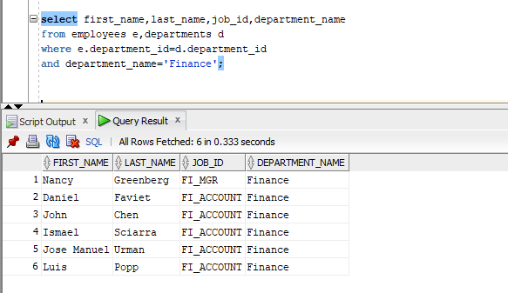

select first_name,last_name,job_id

from employees

where department_id in(select department_id from departments where department_name='Finance')

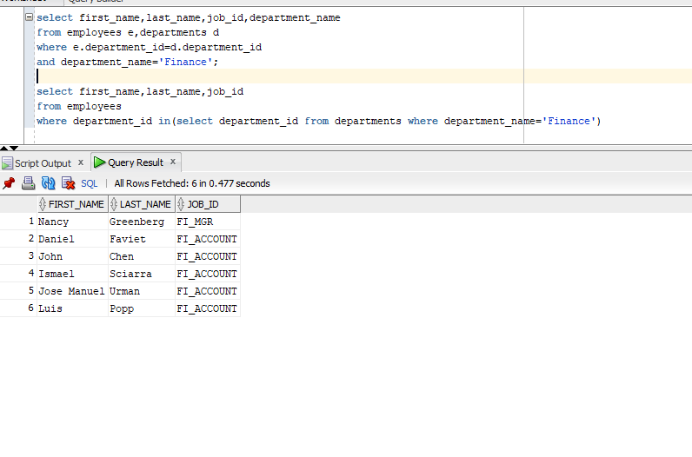

Write a query to display all the information for those employees whose id is any id who earn the second highest salary.

select * from employees

where department_id in(select department_id from employees e where (select count (distinct y.salary)

from employees y where e.salary<=y.salary)in(2))

or

select * from employees

where department_id in (select department_id from employees where

salary=(select max(salary) from employees where

salary<(select max(salary) from employees)))

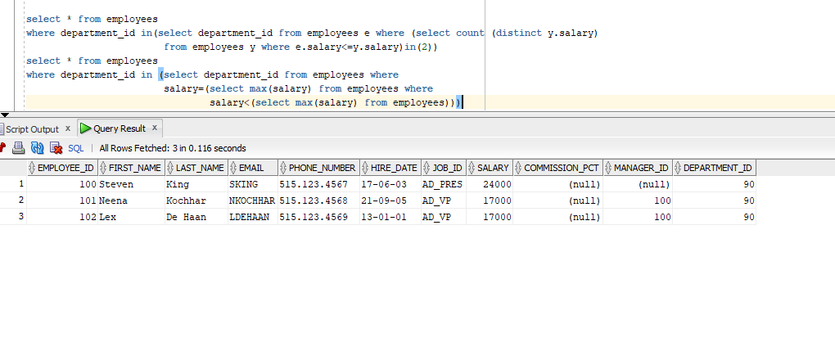

Write a query to display the employee number, name (first name and last name),

and salary for all employees who earn more than the average salary

and who work in a department with any employee with a J in their name.

select employee_id,first_name,last_name,salary

from employees

where department_id in(select department_id from employees where

salary>(select avg(salary) from employees)

and first_name like '%J%')

or

SELECT employee_id, first_name,last_name, salary

FROM employees

WHERE department_id IN (SELECT department_id

FROM employees

WHERE first_name like '%J%')

AND salary > (SELECT AVG(salary)FROM employees);

or

select employee_id, first_name, last_name, salary from hr.employees where

salary > (select avg(salary) from hr.employees) and department_id IN

(select department_id from hr.employees where first_name like '%J%')

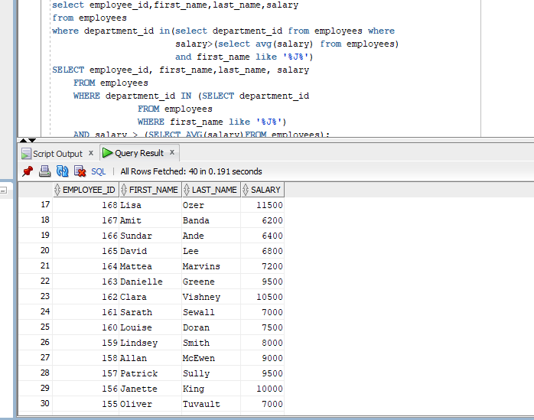

Write a query to display the employee number, name (first name and last name) and job title for all employees whose salary is smaller than

any salary of those employees whose job title is MK_MAN.

select employee_id,first_name,last_name,job_id

from employees

where salary<(select salary from employees where job_id='MK_MAN')

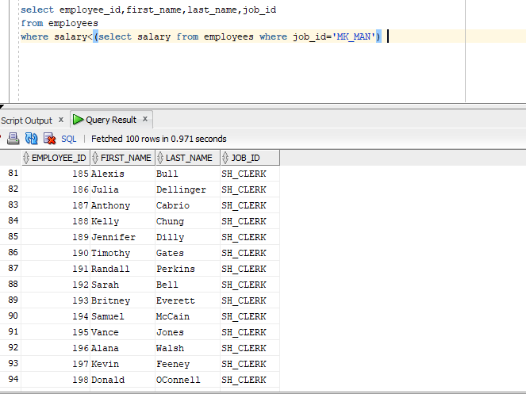

Write a query to display the employee name( first name and last name ) and department for all employees

for any existence of those employees whose salary is more than 3700.

select employee_id,first_name,last_name,department_id

from employees

where exists(select salary from employees where salary>3700)

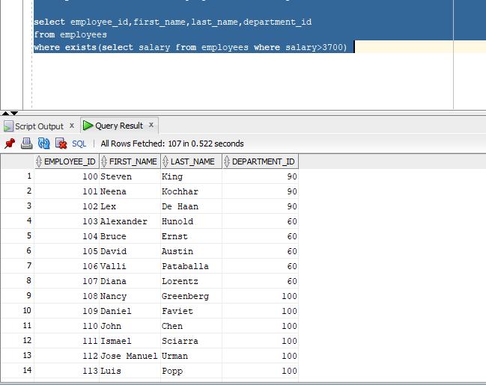

Write a query that will identify all employees who work in departments located in the United Kingdom.

select *

from employees

where department_id in(select department_id from departments where

location_id In(select location_id from locations where

country_id in(select country_id from countries where

country_name='United Kingdom')));

select * from employees e

inner join departments d

on e. department_id=d. department_id

inner join locations l

on d.location_id=l.location_id

inner join countries c

on l.country_id=c.country_id

where c.country_name='United Kingdom';

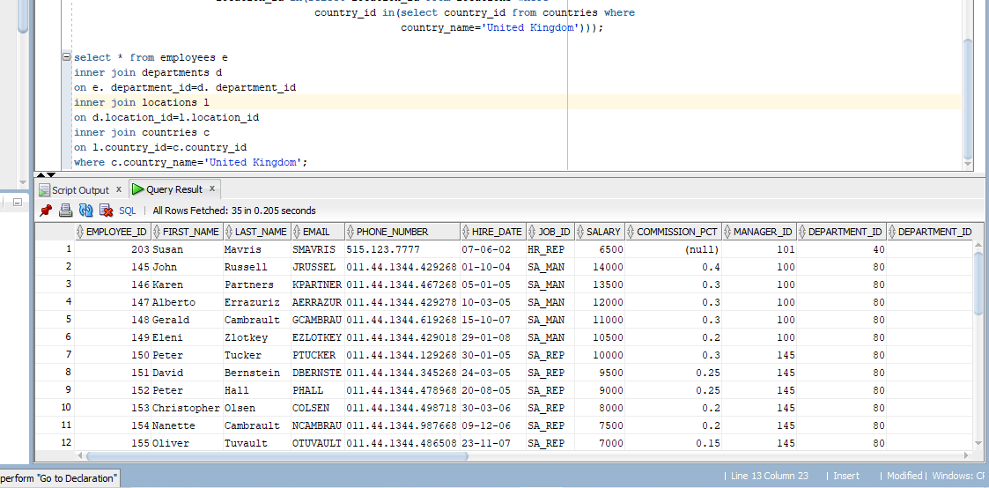

Write a query to get the details of employees who manage a department.

select * from employees

where employee_id in(select manager_id from departments)

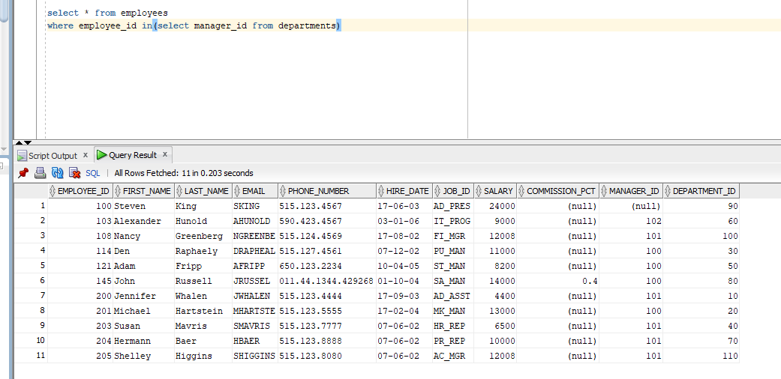

SELECT a.employee_id, a.first_name, a.last_name, a.salary, b.department_name, c.city

FROM employees a, departments b, locations c

WHERE a.salary =

(SELECT MAX(salary)

FROM employees

WHERE hire_date BETWEEN '01-01-2002' AND '31-12-2003')

AND a.department_id=b.department_id

AND b.location_id=c.location_id;

